Simulated utilities:

Automatic Light

Using the values received, and Arduino, the intensity of light can be controlled in different manners. This is achieved through a combination of sensors, actuators, and a control algorithm.

1. Light Sensors: These are crucial components that measure the ambient light in the environment. The most common type used in these applications is the photoresistor or Light Dependent Resistor (LDR). The resistance of an LDR decreases with increasing light intensity.

2. Actuators: In the context of an automatic light control system, the actuator is typically a relay connected to the light source. The relay can switch the light on or off based on the signal it receives from the Arduino.
3.Control Algorithm: This is the brain of the system. It takes the input from the light sensor, processes it, and sends a signal to the actuator. The algorithm can be programmed to maintain a certain light level. For instance, if the sensor detects that the ambient light has fallen below a certain threshold, it will signal the actuator to switch on the light. Conversely, if the ambient light is above the threshold, the light will be switched off.

This system can be further enhanced by integrating it with other home automation systems, allowing for more complex behaviors. For example, the lights could be programmed to slowly dim as it gets closer to bedtime, helping to promote better sleep hygiene.

Arduino Automatic Light Using LED
In the circuit, the values from the photoresistor are obtained and used to control the LED’s brightness. The photoresistor’s resistance changes with light intensity, which in turn changes the voltage across it. This voltage is read by the Arduino, which then adjusts the current flowing to the LED, thereby controlling the LED’s light intensity.
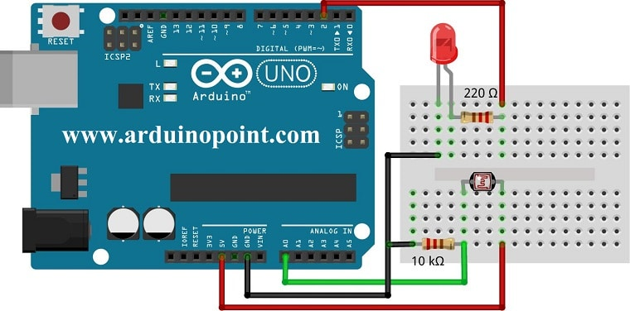
https://arduinopoint.com/ldr-arduino-project/

Arduino Automatic Light Using Relay Schematics
The relay is a switch controlled by an electrical signal. In this project, it’s used to control a bulb. Like the LED, but the voltage is being sent to a 5V Relay Module, that acts like a bottleneck and tells the module how much current to send to the lght bulb.
It is connected to NO, normally open pin, which means the common pin is connected only if the relay is triggered, and in this case, it’s triggered by the voltage received from the board.
This circuit might be dangerous, touching the circuit might be the same as sticking one’s finger inside a power outlet’s socket.
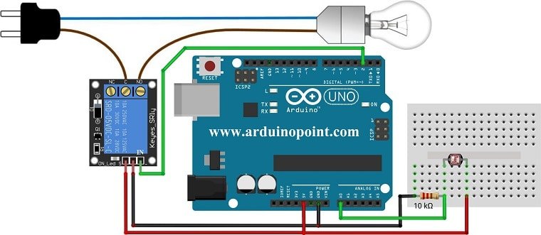
https://arduinopoint.com/ldr-arduino-project/

Light Tracker

Arduino Automatic Light Tracker
The circuit is the same as in the LED, expect there should be at least two photoresistors to get the information on the brightest spot around the light tracking object. The Arduino reads the voltage from the photoresistors and uses this information to control a micro-servo motor. The motor rotates a light tracker towards the brightest point. This allows the light tracker to continuously follow the brightest light source in real-time.
